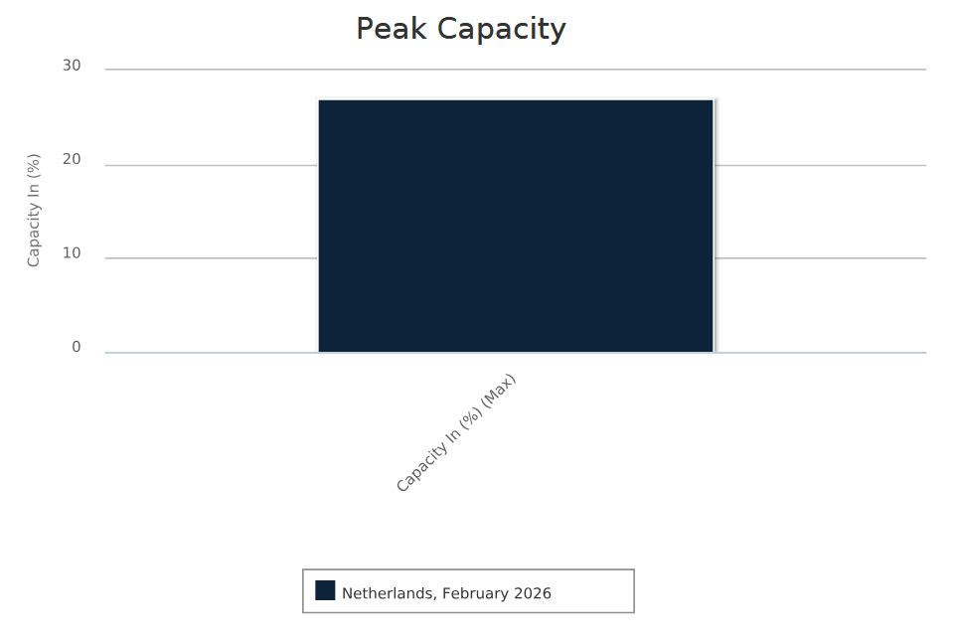

This disclosure is made pursuant to the Commitments offered by Liberty Global to the European Commission in case M.7000 - Liberty Global / Ziggo.

The data shown represents the highest daily 95th percentile peak ingress utilization in the relevant month of aggregated interconnect capacity in The Netherlands from Internet connectivity providers with whom Liberty Global directly interconnects with.

