Mike Fries | Chief Executive Officer - Liberty Global

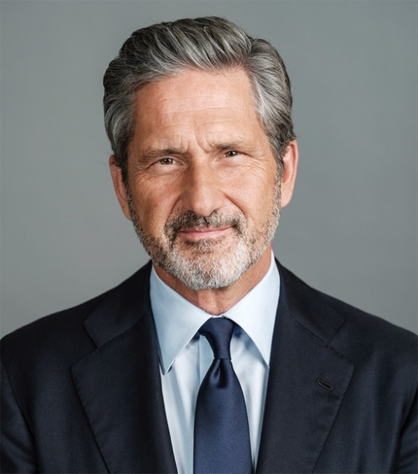
Mike Fries is Chief Executive Officer and Vice Chairman of Liberty Global, a world leader in converged broadband, video and mobile communications and an active investor in cutting-edge infrastructure, content and technology ventures.

Liberty Global delivers next-generation products through advanced fiber and 5G networks, providing over 85 million connections* across Europe and the UK. Its businesses operate under some of the best-known consumer brands, including Virgin Media-O2 in the UK, VodafoneZiggo in The Netherlands, Telenet in Belgium, Sunrise in Switzerland, Virgin Media in Ireland and UPC in Slovakia. The joint ventures in the UK and the Netherlands generate combined annual revenue of over $18 billion**, while remaining operations generate consolidated revenue of more than $7 billion. Through its substantial scale and commitment to innovation, Liberty Global is building Tomorrow’s Connections Today, investing in the infrastructure and platforms that empower customers and deploying the advanced technologies that nations and economies need to thrive.
As a member of the management team that founded the company over 30 years ago, Fries launched the company’s international expansion, and has served in various strategic and operating capacities since that time. He was appointed Chief Executive Officer of the company in 2005 and serves as a member of its two-person Executive Committee along with Chairman, Dr. John C. Malone.
Fries is also Executive Chairman of Liberty Latin America (LLA), a leading communications company with operations in Puerto Rico, the Caribbean and other parts of Latin America that serves 12 million broadband, video, voice and mobile subscribers and generates $4.5 billion of annual revenue. LLA was split off from Liberty Global to focus purely on organic and strategic growth in the region. Fries also serves on the corporate boards of Grupo Televisa and Lionsgate Entertainment.
Fries is an engaged industry and community leader. He serves as board member for Cable Labs, and is a trustee and finance committee member of The Paley Center for Media and an ICT Governor of the World Economic Forum. He is Honorary Co-Chair for the Biennial of the Americas and is Trustee Emeritus and former Chair of the Museum of Contemporary Art Denver. Recognition for his achievements includes EY Entrepreneur of the Year in Media, Entertainment and Telecommunications, and inductions into the Broadcasting & Cable Hall of Fame and the Cable Hall of Fame, which recognize pioneers and leaders in the media, communications and cable industries. Mike holds a B.A. from Wesleyan University, where he is a Trustee Emeritus, and an M.B.A. from Columbia University, where he is a member of the Board of Overseers for the Business School.
* Represents aggregate consolidated and 50% owned non-consolidated fixed and mobile subscribers. Includes wholesale mobile subscribers of the VMO2 JV and B2B fixed subscribers of the VodafoneZiggo JV. ** Revenue figures above are provided based on the combined as reported full-year 2023 results for the VodafoneZiggo JV and full-year 2023 U.S. GAAP results for the VMO2 JV.

