**Mike Fries** | Chief Executive Officer - Liberty Global

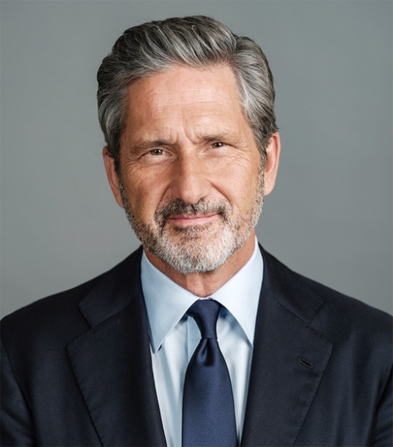Mike Fries is Chief Executive Officer and Vice Chairman of Liberty Global, a world leader in converged broadband, video and mobile communications. Liberty Global delivers next-generation products through advanced fiber and 5G networks that connect 85 million subscribers across Europe and the UK. Its businesses operate under some of the best-known consumer brands, including Virgin Media O2 in the UK, VodafoneZiggo in The Netherlands, Telenet in Belgium, Sunrise UPC in Switzerland, Virgin Media in Ireland and UPC in Eastern Europe. The joint ventures in the UK and the Netherlands generate combined annual revenue of over $17 billion, while remaining operations generate consolidated revenue of more than $7 billion[1]. Through its substantial scale and commitment to innovation, Liberty Global is building *Tomorrow’s Connections Today*, investing in the infrastructure that empowers customers and deploying the advanced technologies that nations and economies need to thrive.

As a member of the management team that founded the Company over 30 years ago, Fries launched the company’s international expansion, and has served in various strategic and operating capacities since that time. He was appointed Chief Executive Officer of the Company in 2005 and serves as a member of its two-person Executive Committee along with Chairman, Dr. John C. Malone.

Fries is also Executive Chairman of Liberty Latin America (LLA), a leading broadband and mobile operator in Chile, Puerto Rico, the Caribbean and other parts of Latin America that serves 10.8 million broadband, video, voice and mobile subscriber and generates $4.5 billion of annual revenue. LLA was split off from Liberty Global to focus purely on organic and strategic growth in the region. Fries also serves on the corporate boards of Grupo Televisa and Lionsgate Entertainment.

Fries is an engaged industry and community leader. He serves as board member for Cable Labs and trustee for The Paley Center for Media, and he chairs the boards for the Museum of Contemporary Art Denver and the Biennial of the Americas. He is a Digital Communications Governor and Steering Committee Member of the World Economic Forum and a member of Young Presidents’ Organization. Recognition for his achievements includes EY Entrepreneur of the Year in Media, Entertainment and Telecommunications, Industry Leader of the Year by Digital TV Europe, and inductions into the Broadcasting & Cable Hall of Fame and the Cable Hall of Fame, which recognizes pioneers and leaders in the cable industry. Mike holds a B.A. from Wesleyan University, where he serves on the Board of Trustees, and an M.B.A. from Columbia University, where he is a member of the Board of Overseers for the Business School.

1. Revenue figures based upon 2020 results and on a combined Virgin Media and O2 UK basis.