Mike Fries

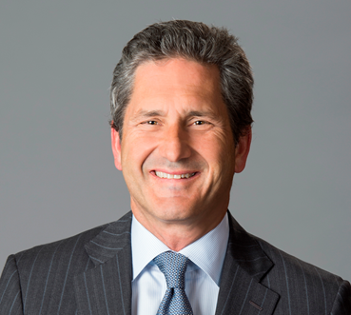
Chief Executive Officer - Liberty Global

Mike Fries is Chief Executive Officer and Vice Chairman of Liberty Global, one of the world’s leading converged video, broadband and communications companies. With operations in seven European countries under the consumer brands Virgin Media, Telenet, UPC, Sunrise UPC and VodafoneZiggo, a 50/50 joint venture, Liberty Global has 30,000 employees, 49 million broadband, video, voice and mobile subscribers and generates aggregate annual revenue of $16.5 billion. Across its markets, the Company is dedicated to building and investing in the products, platforms and infrastructure that enable customers, businesses and communities to make the most of the digital revolution – bringing the possibilities of the future to today. As a member of the management team that founded the Company over 30 years ago, Fries launched the Company’s international expansion, and has served in various strategic and operating capacities since that time. He was appointed Chief Executive Officer of the Company in 2005 and serves as a member of its two-person Executive Committee along with Chairman, Dr. John C. Malone.

Fries is also Executive Chairman of Liberty Latin America (LLA), a leading broadband and mobile operator in Chile, Puerto Rico, the Caribbean and other parts of Latin America. LLA serves 10.6 million broadband, video, voice and mobile subscribers and generates $3.8 billion of annual revenue. LLA was split off from Liberty Global to focus purely on organic and strategic growth in the region. Fries also serves on the corporate boards of Grupo Televisa and Lionsgate Entertainment.

Fries is an engaged industry and community leader. He serves as board member for Cable Labs and trustee for The Paley Center for Media, and he chairs the boards for the Museum of Contemporary Art Denver and the Biennial of the Americas. He is a Digital Communications Governor and Steering Committee Member of the World Economic Forum and a member of Young Presidents’ Organization. Recognition for his achievements includes EY Entrepreneur of the Year in Media, Entertainment and Telecommunications, Industry Leader of the Year by Digital TV Europe, and inductions into the Broadcasting & Cable Hall of Fame and the Cable Hall of Fame, which recognizes pioneers and leaders in the cable industry. Mike holds a B.A. from Wesleyan University, where he serves on the Board of Trustees, and an M.B.A. from Columbia University, where he is a member of the Board of Overseers for the Business School.

